

Name : Yumna Zia

Reg : 235155

Lab 06: A Guided Project

Project Title: Smart Image Enhancement & Analysis System

6.1. Image Acquisition & Understanding (Lab 01)

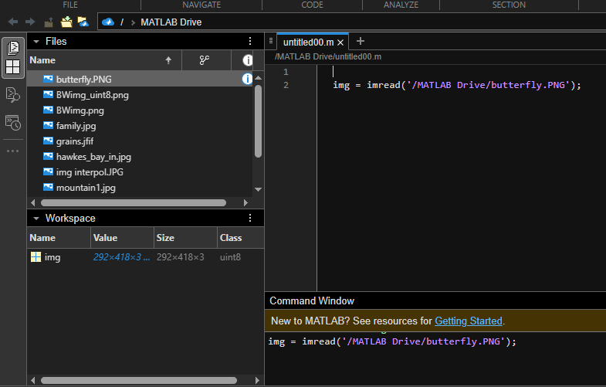
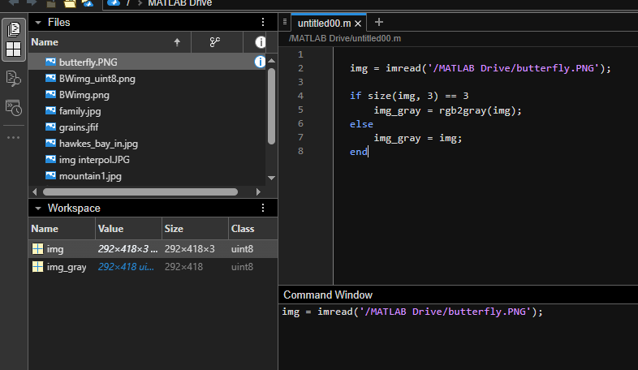
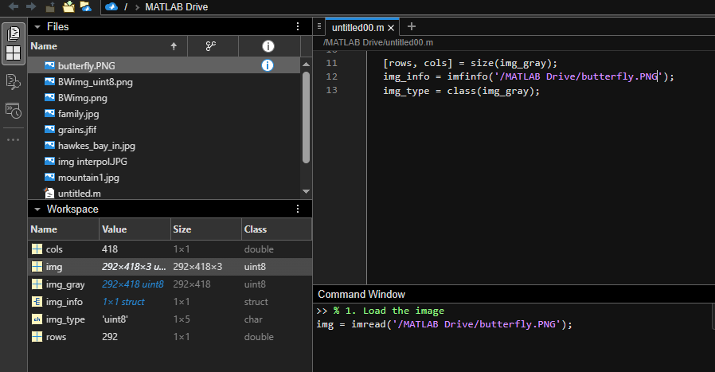
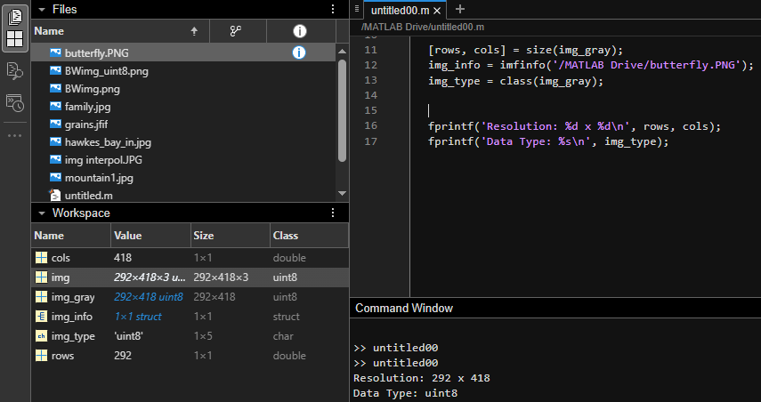
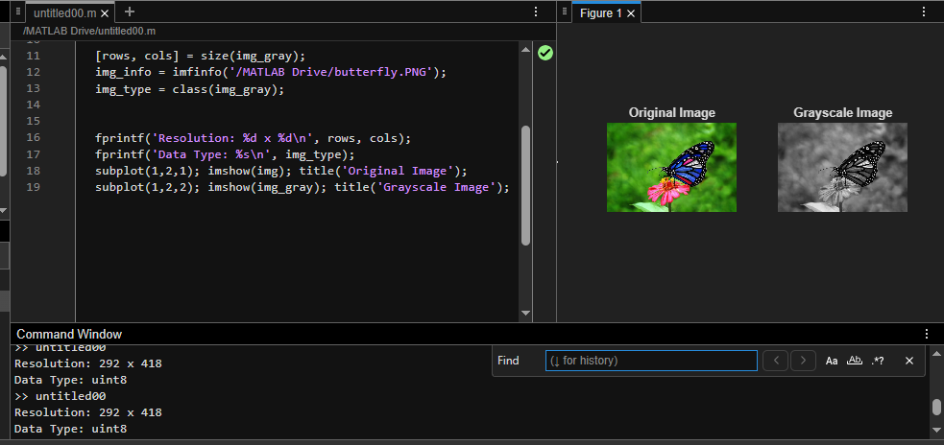
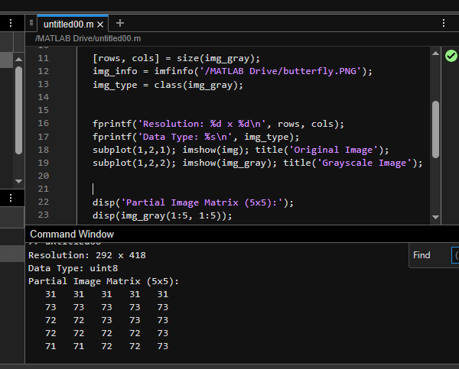

6.2. Sampling & Quantization Analysis (Lab 02)

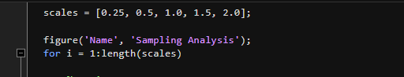
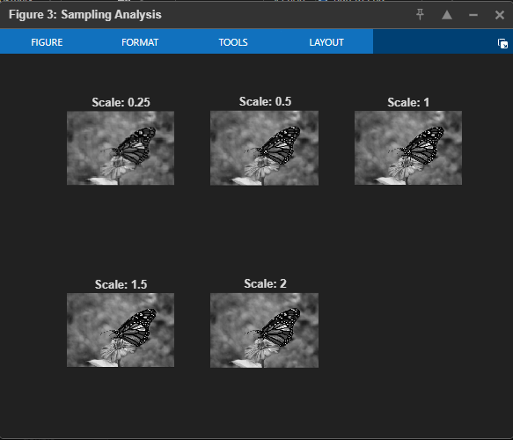
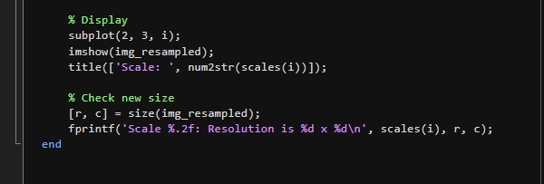

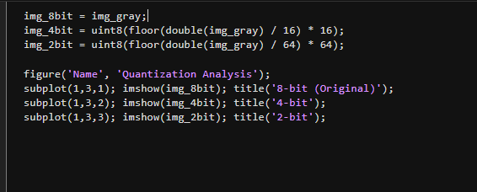

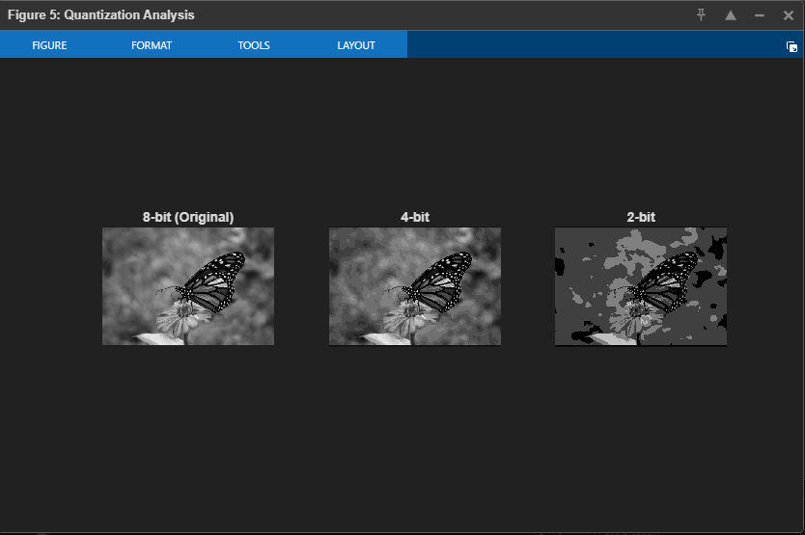
6.3. Geometric Transformations (Lab 03)
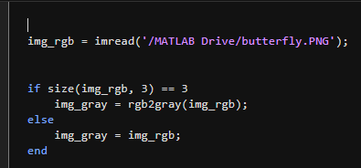
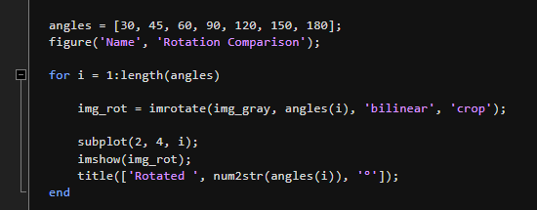
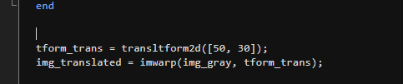
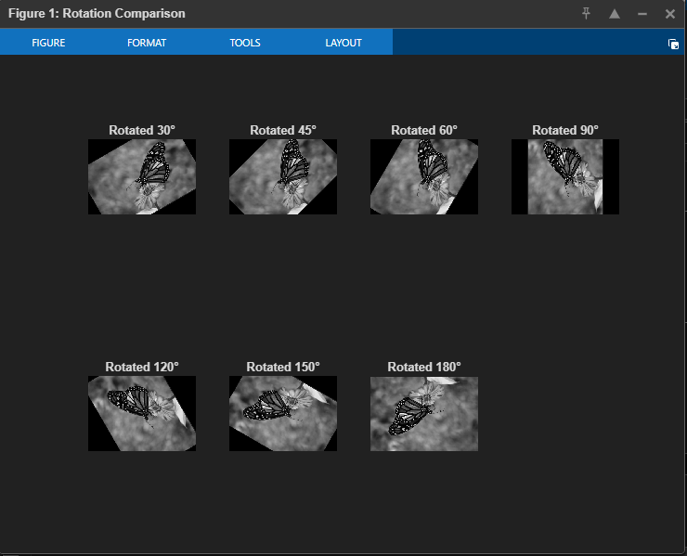
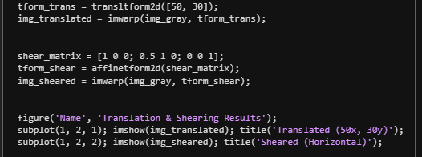

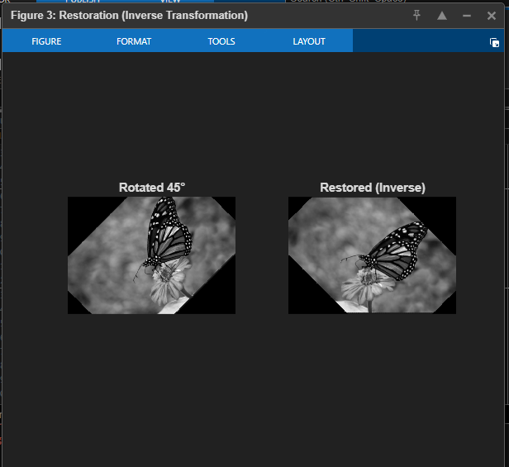
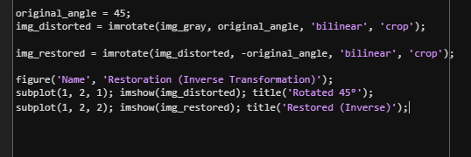
6.4. Intensity Transformations (Lab 04)
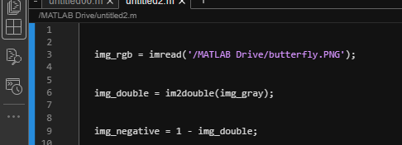

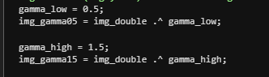
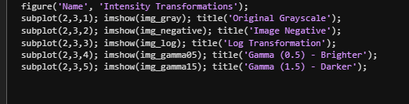
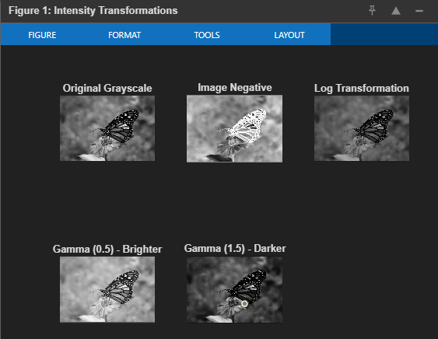
6.5. Histogram Processing (Lab 05)

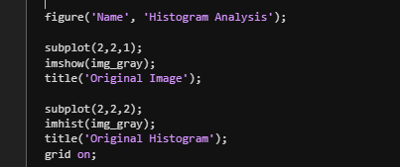
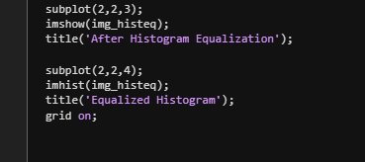

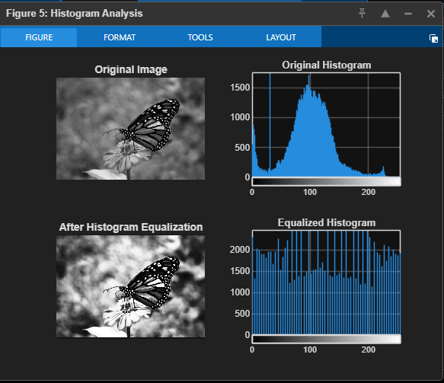
6.6. Final Integrated System

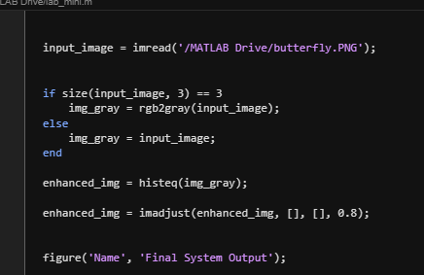
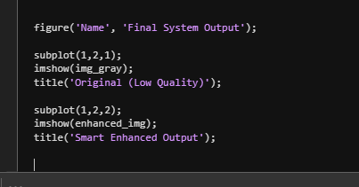
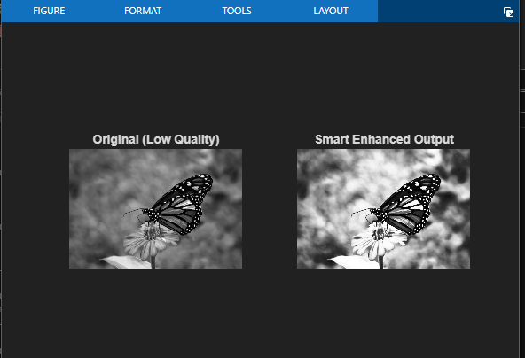
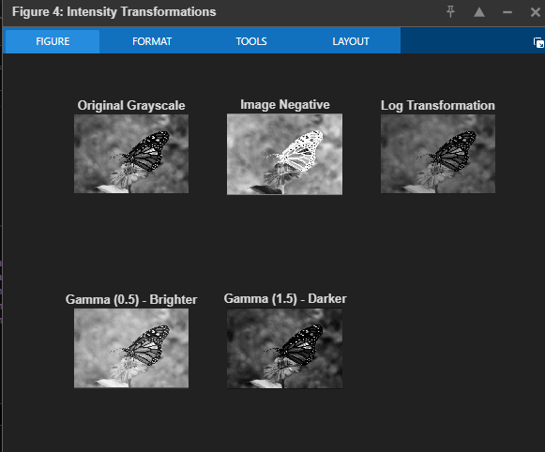
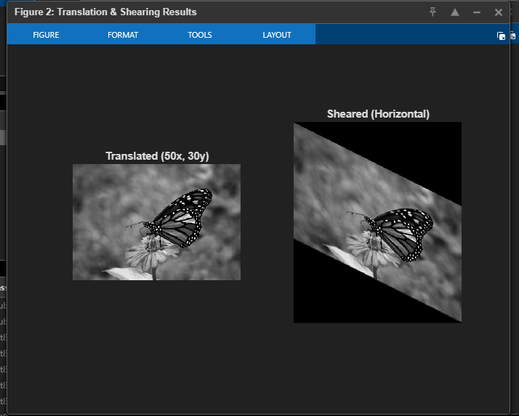

1. Why does histogram equalization improve contrast?
Think of a photo where all the colors are bunched up—maybe it’s too dark or too "gray." This means the "histogram" (the map of all brightness levels) is squeezed into one small spot. Histogram equalization takes those bunched-up pixels and spreads them out across the whole range from black to white. By stretching these values, the dark parts get darker and the light parts get lighter, which makes the image look much sharper and clearer.
2. How does gamma affect brightness?
Gamma is like a "curved" dimmer switch for your image.
Gamma less than 1 (like 0.5): This pushes the middle-tone pixels toward the white end, making a dark image look much brighter.
Gamma more than 1 (like 1.5): This pushes pixels toward the black end, making the image look darker and moodier.
3. What is the effect of quantization on image quality?
Quantization is about how many colors or shades of gray an image can show. If you have high quantization (8-bit), the colors blend smoothly. If you reduce it (like to 2-bit), you run out of shades to show. This causes "false contouring," where smooth areas (like a blue sky or the butterfly's wings) start looking like a paint-by-numbers map with ugly, sharp borders between colors.
4. Which transformation is reversible and why?
Geometric transformations (like Rotating or Moving an image) are generally reversible. This is because they use math (matrices) that can be "undone". For example, if you rotate the butterfly 45 degrees clockwise, you can mathematically rotate it 45 degrees counter-clockwise to get it back to its original spot. However, you might lose a little bit of sharpness in the process because of how pixels are recalculated.
5. How do transformations affect spatial structure?
Spatial transformations change where the pixels are located, not what color they are. When you rotate, shear, or translate (move) an image, you are changing the "structure" or the layout of the objects inside the frame. It’s like moving furniture around a room; the furniture stays the same color, but its position in the space has changed.

